

# QB DOCUMENTATION



#### Document History

|  |  |  |  |  |  |
| --- | --- | --- | --- | --- | --- |
| Date | Version | Revision Details | Author | Reviewed By | Approved By |
| 11-02-2017 | 1.0 | Initial Draft | Sebin Sequira |  |  |
|  |  |  |  |  |  |

**TABLES**

**1) rel_placementtrack:**

Contains data related to placement history. It can be viewed by clicking on any client’s fast facts.

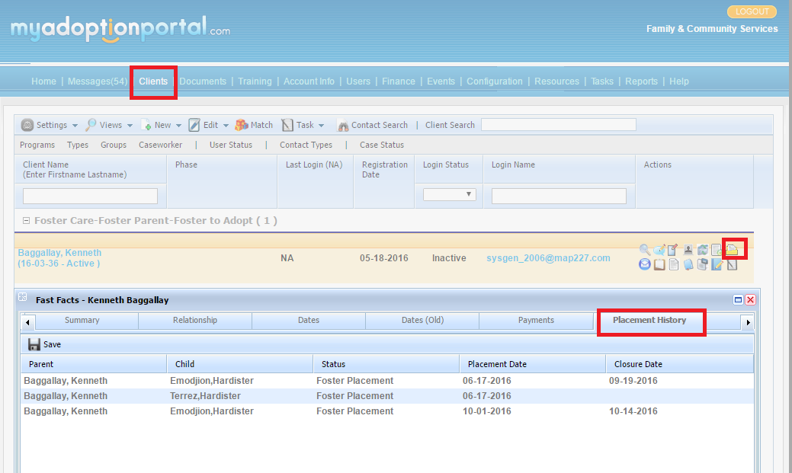

**Column List:**

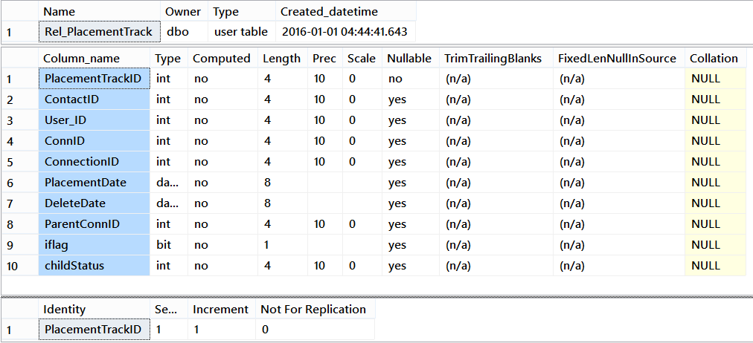

**Column Definitions:**

1. **PlacementTrackID** - Identity field
2. **ContactID** - Foster child’s contact ID
3. **User_ID** - Foster child’s user ID
4. **ConnID** - Foster child’s case connID (select ConnID of child’s case record in rel_relationship table)
5. **ConnectionID** – ID connecting foster parent and foster child (Same for both)
6. **PlacementDate** – placement start date
7. **DeleteDate** – placement closure date
8. **ParentConnID** - Foster parent’s case connID (select ConnID of parent’s case record in rel_relationship table)
9. **Iflag** – Indicates manually inserted records
10. **childStatus** – connection status ID of child (master table - lkpconnectionstatus)

**Join conditions with rel_relationship and lkpconnectionstatus table:**

SELECTr.displaynameasFosterParent

,rr.displaynameasFosterChild

,l.ConnectionStatusTextasChildStatus

,p.PlacementDate

,p.DeleteDate

FROMrel_placementtrackp

INNERJOINrel_relationshipr

ONp.ParentConnID=r.ConnIdandr.RelationshipTypeId=-101

INNERJOINrel_relationshiprr

ONp.ConnID=rr.ConnIdandrr.RelationshipTypeId=-104

LEFTJOINlkpconnectionstatusl

ONp.childStatus=l.ConnectionStatusId

**STORED PROCEDURES**

**1) Usp_FCBillingReport -** Used for retrieving data in Foster Care Report under Finance tab.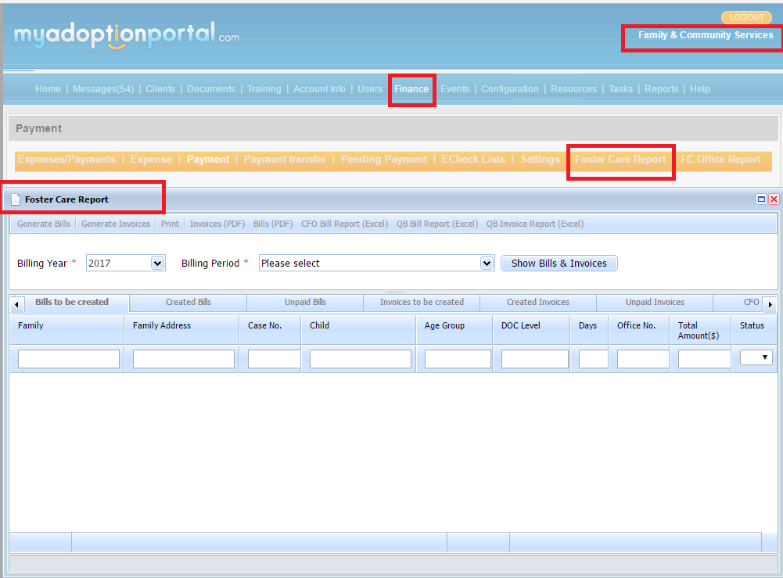

SP is saved in **MAPSSRS** DB.

**Input Parameters :**

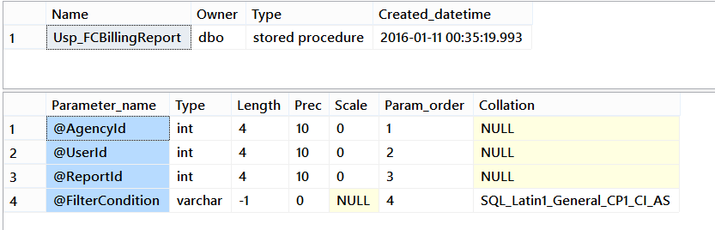

**Sample execution format :** EXEC[mapssrs].[dbo].[Usp_FCBillingReport] 234,0,0,'Billing_Date Between ''2016-12-26'' And ''2017-01-08'''

**MERGING SCRIPTS**

Used for merging different agency’s data. For “Family & Community Services” agency, scripts were created for merging adoption and foster care programs.

|  |  |  |  |
| --- | --- | --- | --- |
| **Agency Name** | **DB Name** | **Programs** | **Status** |
| Family Adoption Consultants - A Program of Family | MAPfac_OLD_Test | Adoption | Old (Data before merging) |
| Family & Community Services | MAPFC_OLD_Test | Foster Care | Old (Data before merging) |
| Family & Community Services | MAPFCS | Adoption, Foster Care | Live |

**MAPFCS** DB was created by copying **MAPFC_OLD_Test.**

But there are changes related to **MAPfac_OLD_Test** DB -

1. Added **100000** to all ID's (contactID, User_ID, ConnID, ConnectionID etc)
2. Changes to other identity fields (RelationshipSubTypeId (program ID), RelationshipTypeId (Role ID), group_id, task_id, stage_id, phase_id etc )